Finite State Machines for the following:

1. Handle outgoing calls using number keypad/verbal/speed dialing methods



1. Dial voicemail service

Expected Result: Voicemail service offers missed voicemails

2. Recognize speech and dial requested number

Expected Result: Given contact number is dialed if valid

3. Dialed using keypad

Expected Result: Given contact number is dialed if valid

4. Dialed through speed contact

Expected Result: Given contact number is dialed if valid

5. Invalid number dialed

Expected Result: Prompt back for retry

6. Valid number dialed

Expected Result: Request region of both devices

7. Same region

Expected Result: Request communication channels from base station

8. Different region

Expected Result: Disconnect the call

9. Receiver busy

Expected Result: Disconnect the call

10. Receiver out of network

Expected Result: Disconnect the call

11. Receiver available

Expected Result: Occupy offered channel

12. Successful connection

Expected Result: Initiate session

13. Call drop request from receiver side

Expected Result: Disconnect the call

14. Drop the call

Expected Result: Disconnect the call

15. Successful termination of the call

Expected Result: Cell state updated back to idle state

16. Unsuccessful termination of the call

Expected Result: Redial the contact number

2. Handle incoming call



1. Incoming call request arrives

Expected Result: Update cell state to busy

2. Ring the cell

Expected Result: Start ringing until incoming call gets responded or time out occurs

3. Answer the incoming call

Expected Result: Attempt to connect to network channel

4. Call Rejected

Expected Result: Release occupied channels if any

5. Call Timed Out

Expected Result: Release occupied channels if any

6. Connection Failed

Expected Result: Release occupied channels if any

7. Connection Established

Expected Result: Occupy the channel offered by local base station

8. Call drop request from receiver side

Expected Result: Disconnect the call

9. Drop the call

Expected Result: Disconnect the call

10. Successful termination of the call

Expected Result: Cell state updated back to idle state

Question 2:

1. Screenshot of the Test cases: Test passed

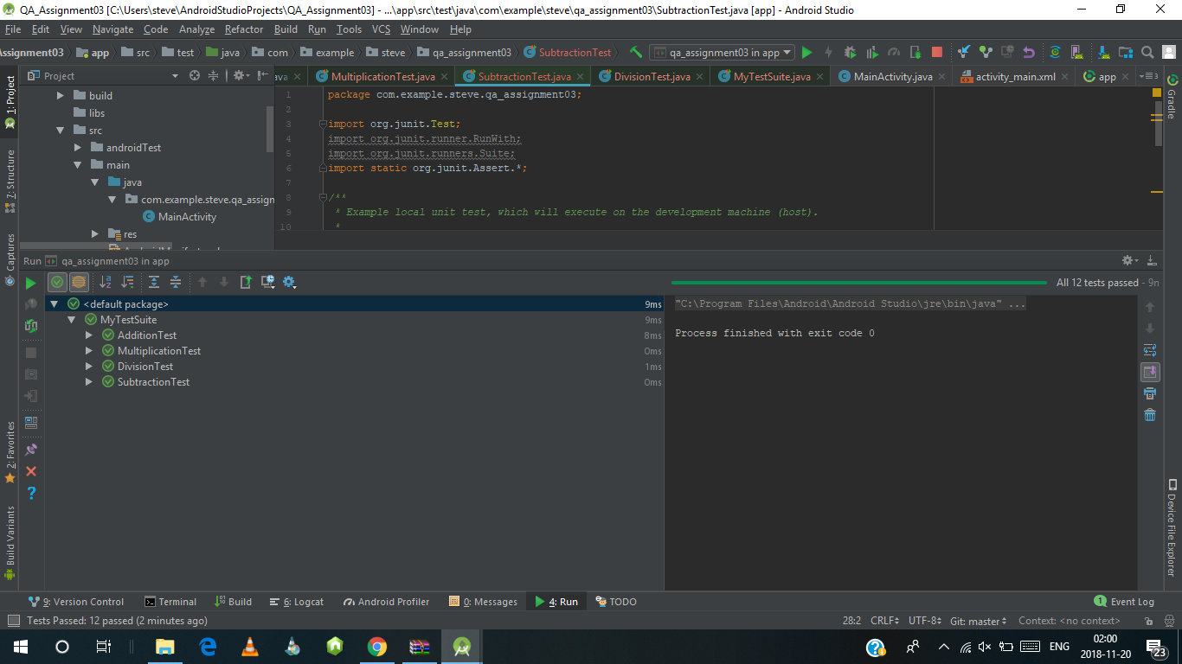

1. Create mutant

Change division into multiplication

1. Re-run of the Test

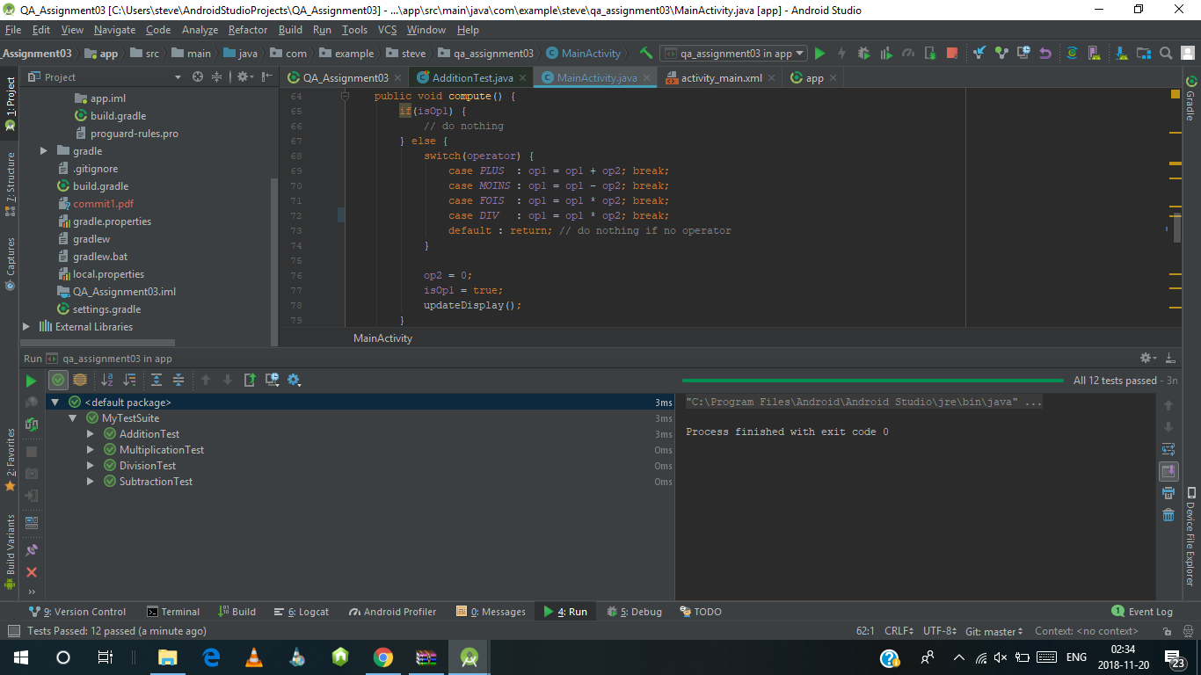

1. The result of unit test was pass.
2. argument (1,1), (2,1),(9,3)

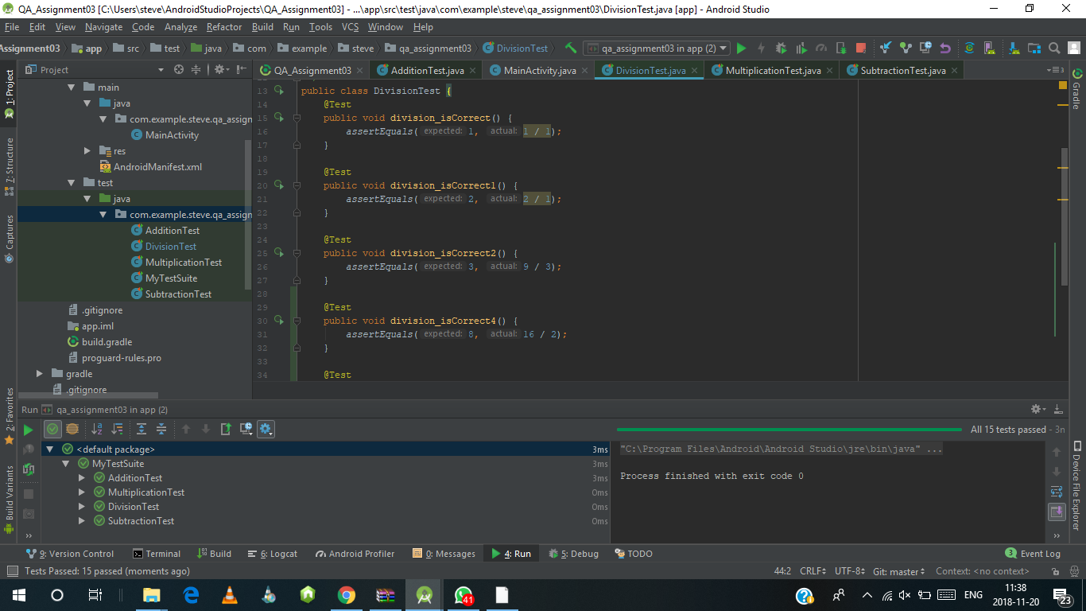

1. The result of the unit test in this was pass. It tell us us that the test case we implement was not strong enough to detect the change in the program .

In conclusion we need to change the test case and implement something better that will detect and fail the mutant.

commit

